****************Experiment no:-10*****************

-----------------------------------------------------------------------------------------------------------------------------

Author : Saurabh Khandagale , Mehul Khandhadiya

Roll No:46,55

Date :24-April-2021

-----------------------------------------------------------------------------------------------------------------------------

**AIM:-**

**To develop web/desktop application for the stated case study and prepare documentation for the same.**

**Problem Statement:-**

**Online Examination Registration System Application, Create a complete suite of UML models that include** .

* Use Case Diagrams (with detailed functionality description)
* Class Diagram(s)
* Sequence Diagram(s)
* State-chart Diagrams
* Activity Diagram
* Component-Deployment Diagram

**Use Case Diagrams: Online Examination Registration**

In UML, there are five diagrams available to model the dynamic nature and use case diagram is one of them. Now as we have to discuss that the use case diagram is dynamic in nature, there should be some internal or external factors for making the interaction.These internal and external agents are known as actors. Use case diagrams consists of actors, use cases and their relationships. The diagram is used to model the system/subsystem of an application. A single use case diagram captures a particular functionality of a system.

Purposes of use case diagrams can be said to be as follows −

* Used to gather the requirements of a system.
* Used to get an outside view of a system.
* Identify the external and internal factors influencing the system.
* Show the interaction among the requirements are actors.

**Actors**

* Examiner
* Admin
* Student

**Use Case Diagrams: Online Examination Registration**

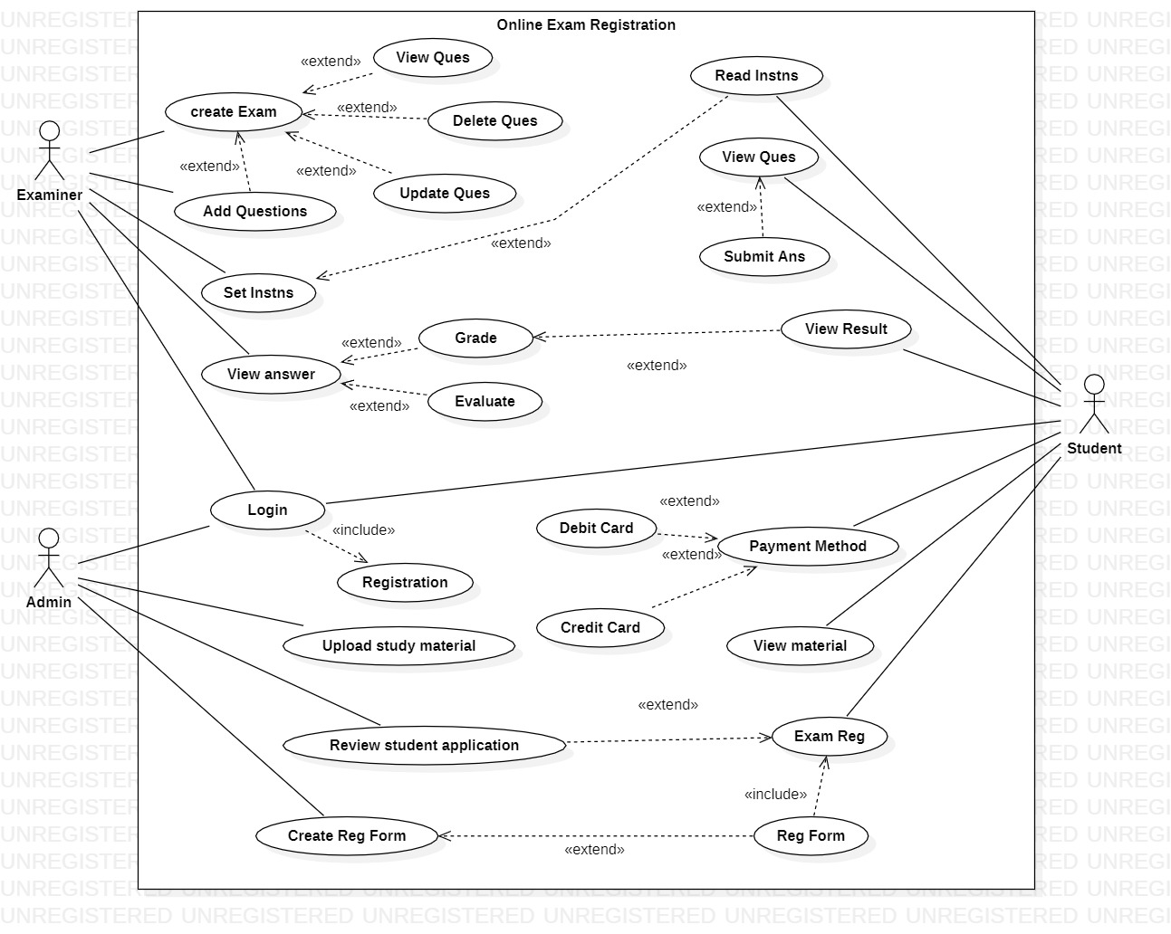

**Class Diagram: Online Examination Registration**

Class diagram is a static diagram. It represents the static view of an application. Class diagram is not only used for visualizing, describing, and documenting different aspects of a system but also for constructing executable code of the software application.

The purpose of the class diagram can be summarized as −

* Analysis and design of the static view of an application.
* Describe responsibilities of a system.
* Base for component and deployment diagrams.

**Classes use:**

* **Test**
* **Test_Question**
* **Online_Exam_System**
* **Student**
* **Administrator**

**Class Diagram: Online Examination Registration**

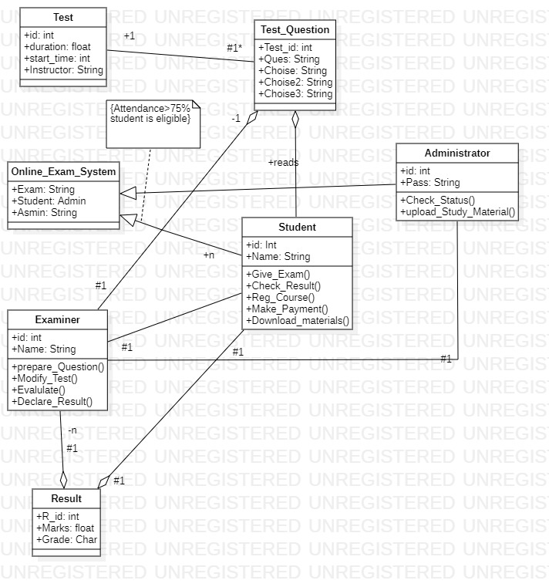

**Sequence Diagram: Online Examination Registration**

Sequence diagrams, commonly used by developers, model the interactions between objects in a single use case. They illustrate how the different parts of a system interact with each other to carry out a function, and the order in which the interactions occur when a particular use case is executed.

**Object**

* **Admin**
* **Examiner**
* **Student**
* **Test**
* **Test_Question**
* **Result**
* **Response**

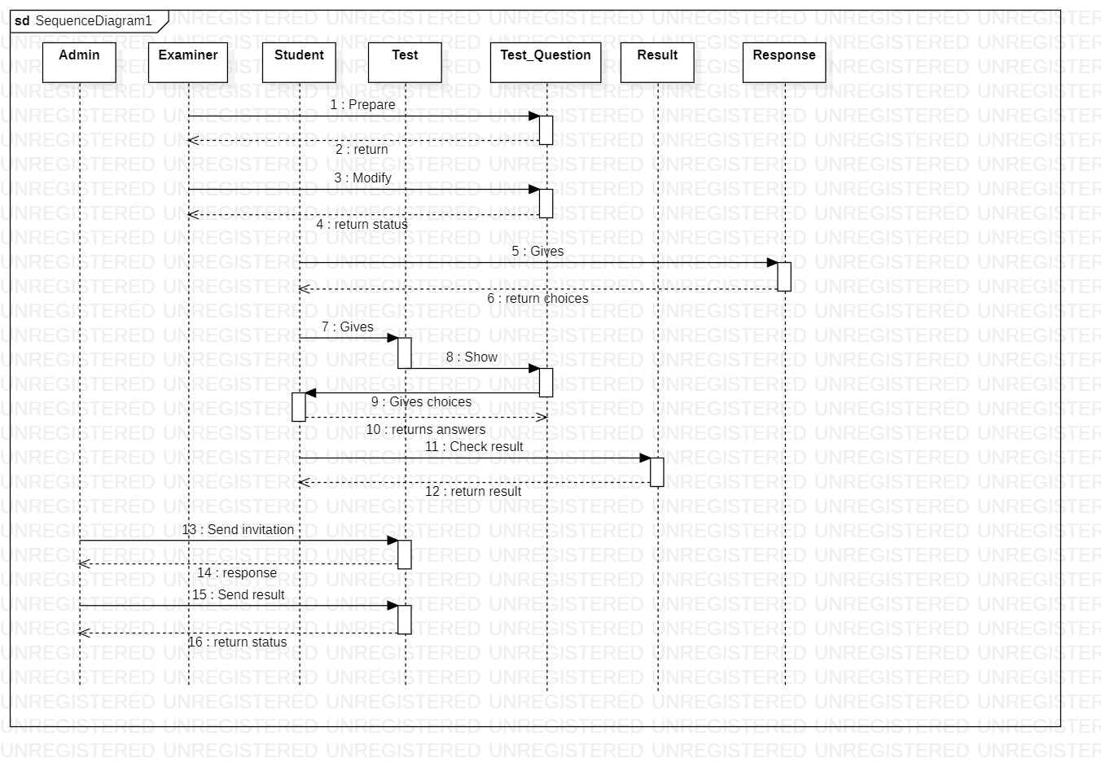

**Statechart diagram: Online Examination Registration**

A Statechart diagram describes a state machine. State machine can be defined as a machine which defines different states of an object and these states are controlled by external or internal events.Activity diagram explained in the next chapter, is a special kind of a Statechart diagram. As Statechart diagram defines the states, it is used to model the lifetime of an object.

Following are the main purposes of using Statechart diagrams −

* To model the dynamic aspect of a system.
* To model the life time of a reactive system.
* To describe different states of an object during its life time.
* Define a state machine to model the states of an object.

**State-Box**

* Login
* Back_To_Login
* Verify_Student_Details
* Exam_Form
* Hall_Ticket
* Result
* Result_Verified
* Submit_Grievance
* Logout

**Statechart diagram: Online Examination Registration**

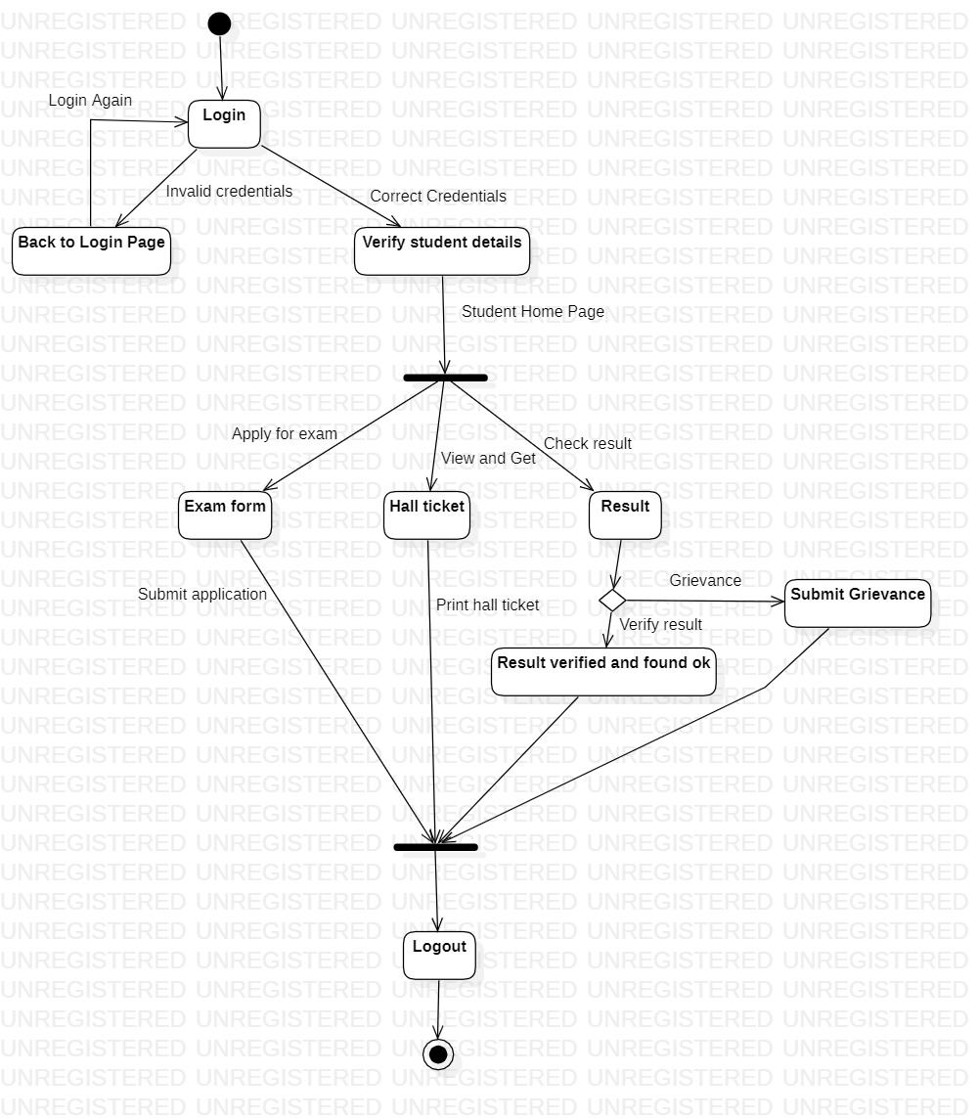

**Activity Diagram: Online Examination Registration**

An activity diagram visually presents a series of actions or flow of control in a system similar to a flowchart or a data flow diagram. Activity diagrams are often used in business process modeling. They can also describe the steps in a use case diagram. Activities modeled can be sequential and concurrent. In both cases an activity diagram will have a beginning (an initial state) and an end (a final state).

**Activity or Action State**

* **Login_Page**
* **Verify_login_details**
* **Display_Student_Details**
* **Apply_Exam**
* **Schedule_exam**
* **Download_hall_ticket**
* **Check_Studey_material**
* **Confirm_exam_requirmnet**

**Activity Diagram: Online Examination Registration**

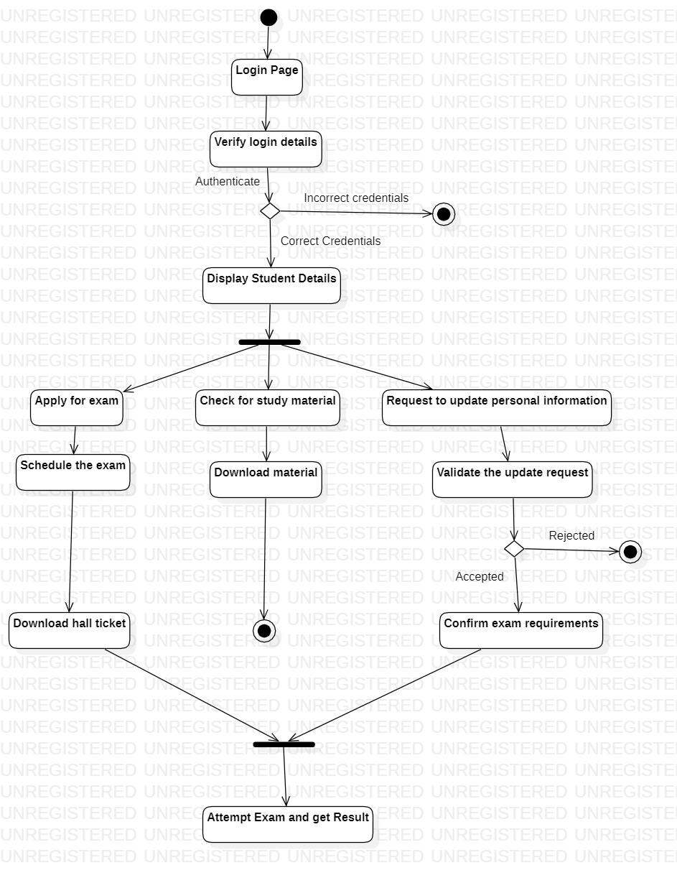

**Component Diagram: Online Examination Registration**

Component diagrams are used to visualize the organization of system components and the dependency relationships between them. They provide a high-level view of the components within a system.

* Are used in Component-Based-Development to describe systems with Service-Oriented-Architecture
* Show the structure of the code itself
* Can be used to focus on the relationship between components while hiding specification detail
* Help communicate and explain the functions of the system being built to stakeholders.

**Componenet use:-**

* Online_Exam_System
* Examination System
* Student_Info

**Interface Use:**

* Admin
* Student
* Acess_Account
* Check_Exam_Details

**Component Diagram: Online Examination Registration**

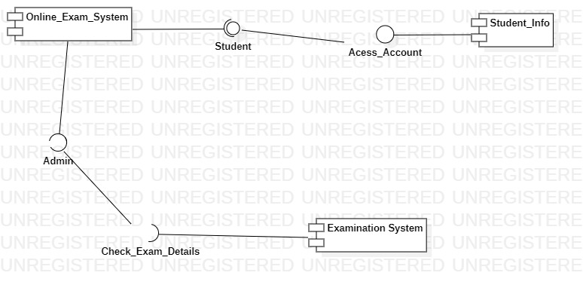

**Deployment diagrams** : **Online Examination Registration**

Deployment diagrams are used to visualize the topology of the physical components of a system, where the software components are deployed. Deployment diagrams are used to describe the static deployment view of a system. Deployment diagrams consist of nodes and their relationships.

The purpose of deployment diagrams can be described as −

* Visualize the hardware topology of a system.
* Describe the hardware components used to deploy software components.
* Describe the runtime processing nodes.

**Node:**

* Admin_node
* Web_Server
* Local_Network
* Student_Server
* Exam_Server
* DBA_Server

**Component:**

* Online_Exam_System
* Student_Info
* Examination System

**Deployment diagrams** : **Online Examination Registration**

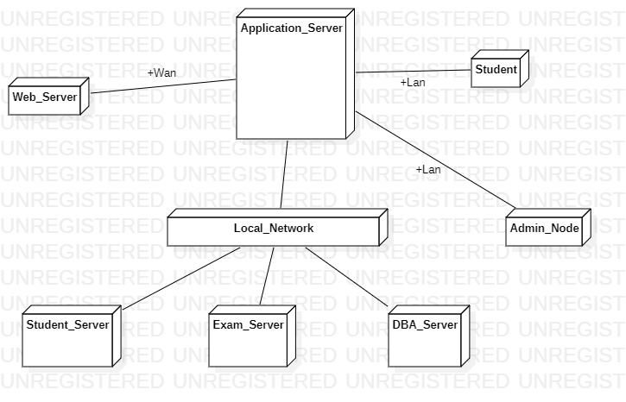

**Conclusion** : Hence ,we have develop Use Case Diagrams Class Diagram(s),Sequence Diagram(s),State-chart Diagrams,Activity Diagram, Component-Deployment Diagram for Online Examination Registration**.**